**Unit 9 What’s the fastest animal in the world ?**

1.Look and write the missing letters.

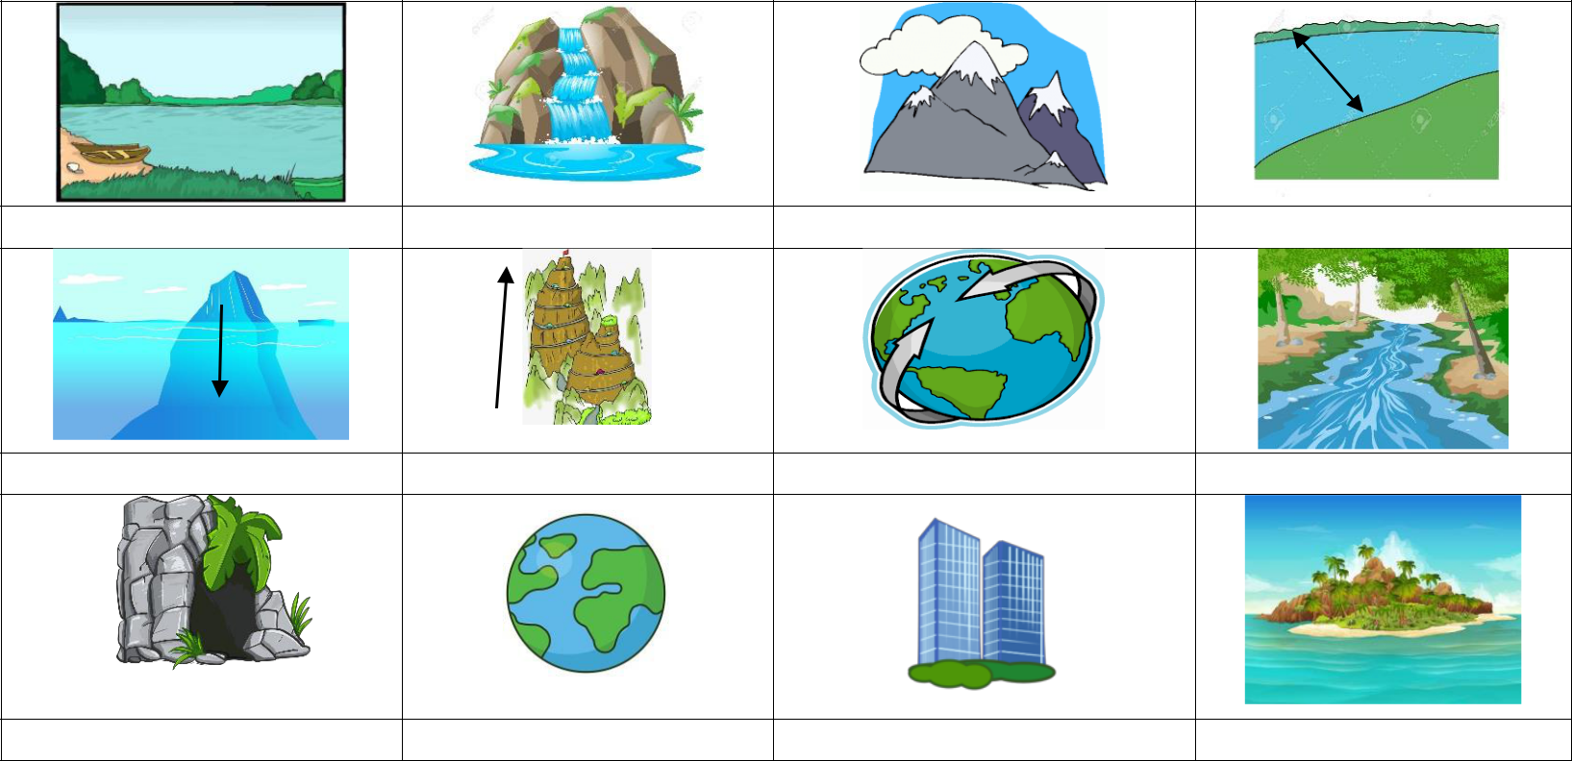

|  |  |  |  |
| --- | --- | --- | --- |
| la _ _ | water _ _ll | mount _ _ _ | wi _ _ |

|  |  |  |  |
| --- | --- | --- | --- |
| de _ _ | hi _ _ | oce _ _ | ri _ _ _ |

|  |  |  |  |
| --- | --- | --- | --- |
| _ |  |  |  |
| ca _ _ | w _ _ ld | b _ _ lding | isl _ _ _ |

2.Write sentences,using the comparative adjective of the word in brackets.

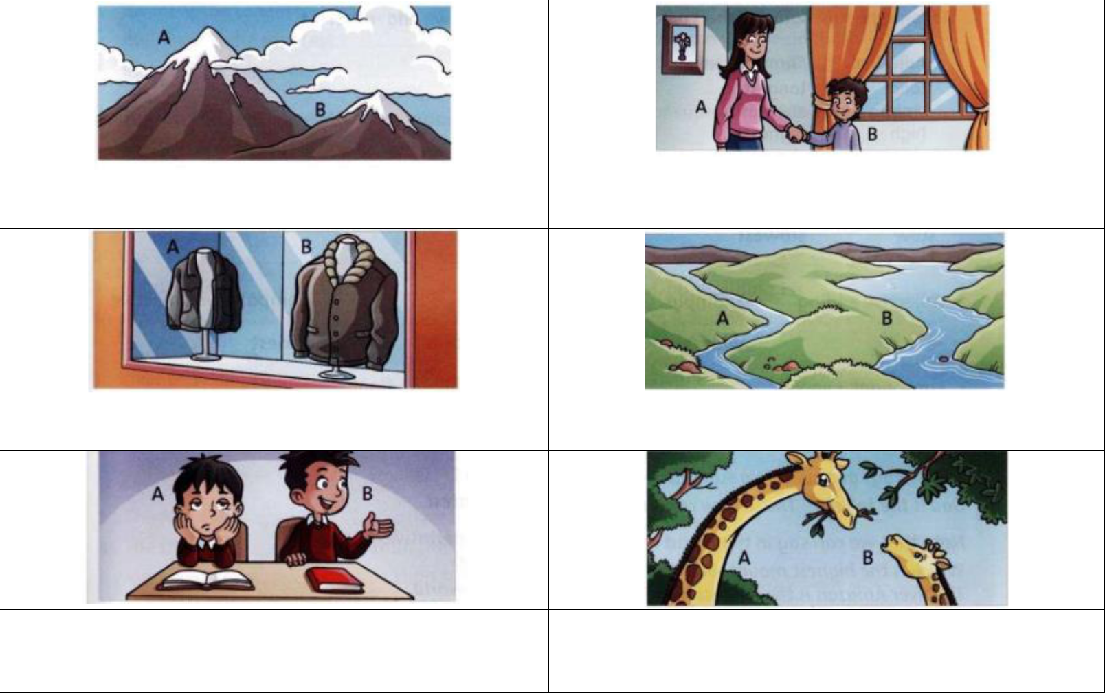

|  |  |
| --- | --- |
| 1. (high) A is higher than B | 2. (old) *………………………………………………..* |

3.(big) *………………………………………………..* 4. (wide) *………………………………………………..*

|  |  |
| --- | --- |
| 5.(quiet) | 6.(tall ) *………………………………………………..* |
| *………………………………………………..* |  |

**Unit 9 What’s the fastest animal in the world ?**

3.Complete the sentences. Use the comparative form of the adjective in brackets.

1. The River Nilde is **longer than** River Thames.(long )
2. My sister is __________________ me . (old)
3. Cario is ______________________ London. (big)
4. Drinking water is______________________ drinking coke.(healthy)
5. The sun is ________________ the moon. (hot )
6. Ben is _____________ his brother ( tall )
7. Winter is ________________ summer (cold)
8. The earth is ________________ the moon.( large )
9. A train is _________________ a plane. ( slow)
10. A mouse is _____________________ a horse (short)
11. This mountain is _________________ that mountain (tall )
12. A rabbit is _____________________ a snail.(fast )